Q. No. | Section-A (21 x 1 = 21 Marks) | Marks
1. | True | 1
2. | Error(D) | 1
3. | False(B) | 1
4. | 8,15(B) | 1
5. | @50 otnmx SC (D) | 1
6. | 19 %16 %13 %10 % | 1
7. | Ans:8 | 1
8. | Select department, sum(commission) from techno group by department having count (*) > 2; | 1
9. | Some error occurred! (B) | 1
10. | None (C) | 1
11. | 0:3 (D) | 1
12. | 6##6 (A) | 1
13. | Update (A) | 1
14. | Perfect (C) | 1
15. | BETTER@late@Than (B) | 1
16. | SUM(Marks) (C) | 1
17. | TCP (A) | 1
18. | Fiber optic cable (C) | 1
19. | Gateway (A) | 1
20. | Both A and R are True and R is the correct explanation for A. (A) | 1
21. | A is True but R is False. (C) | 1
Q. No. | Section-B (7 x 2=14 Marks) | Marks
22. | A. Mutable Data Types: Mutable objects can be changed after they are created — i.e., you can modify, add, or remove elements without creating a new object. Examples: list, dict, set  Immutable Data Types: Definition: Immutable objects cannot be changed after creation — any modification creates a new object. Examples: int, float, str, tuple  OR  B.  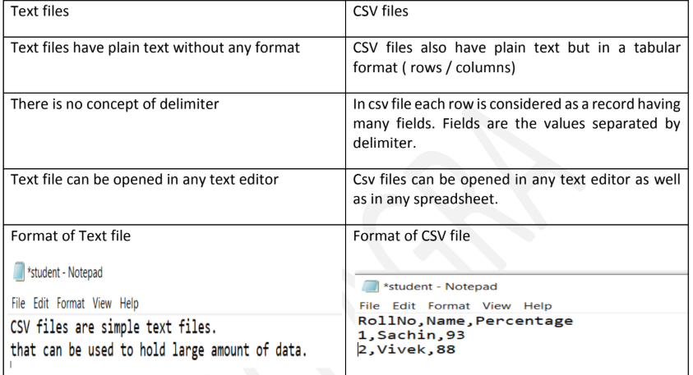 | 2
23. | vowels = "aeiou"  count = 0  for ch in range(len(vowels)):  if vowels[ch] in vowels:  count = count + 1  return count  print("Total vowels:", countvowel("Computer Science")) | 2
24. | I. MyList.pop(0)  II. NewList.extend(L)  OR  B. I. print(len(var.split()))  II. {'Color2': 'Green'} Blue | 2
25. | def CUBE(L):  New_List=[ ]  for i in L:  if i!= 0:  New_List.append(i**3)  return New_List | 2
26. | 40%K  30%4  20%T  10%6 | 2
27. | A.  I. Use employee;  II. Show tables;  OR  B. 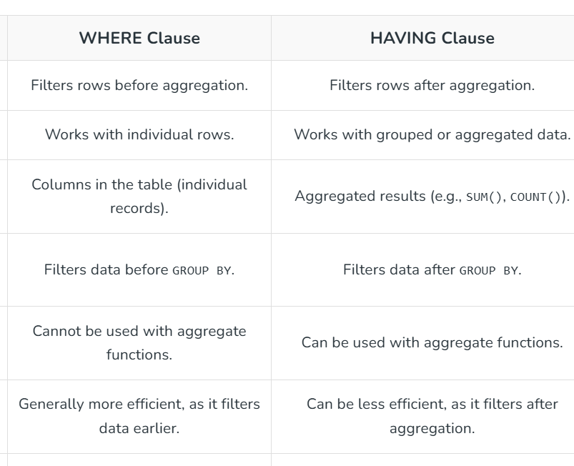 | 2
28. | A.  I. SMTP stands for Simple Mail Transfer Protocol.  It is a communication protocol used to send emails from one computer (or email client) to another through the Internet.  II. VoIP stands for Voice over Internet Protocol.  It is a technology that allows voice communication (calls) to be transmitted over the Internet instead of traditional telephone lines.  OR  B. I. XML - eXtensible Markup Language  URL - Uniform Resource Locator  II.  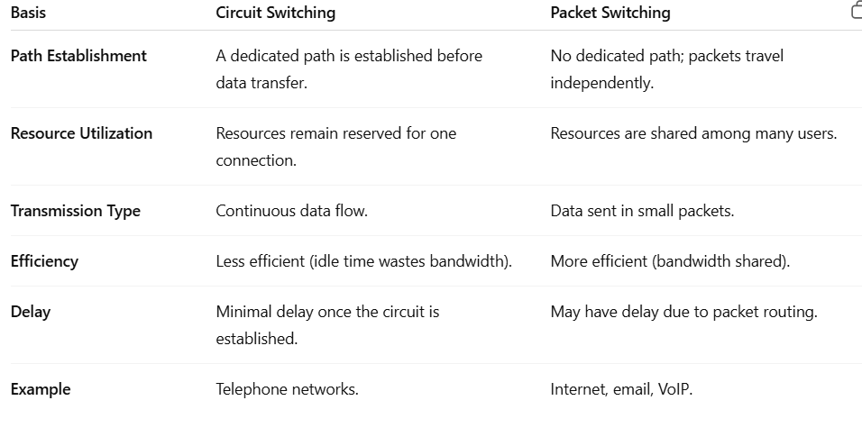 | 2
Section-C (3 x 3 = 9 Marks)
29 | def COUNTTEXT( ):  c = 0  f = open("Sample.txt")  line = f.read()  word = line.split()  for w in word:  if len(w) >4 or w[0] ==’T’ or w[0]==’t’:  c += 1  print(w)  OR  def COUNTWORD( ):  c = 0  f = open("Samplee.txt")  line = f.read()  word = line.split()  for w in word:  if w[-2]=='t':  c=c+1  print(c) | 3
30 | status = []  def Push_element():  for i in patient:  if 25 <= i[4] <= 35:  status.append([i[1], i[2]])  print(status)  def Pop_element():  while True:  if status == []:  print("Stack is empty")  break  else:  record = status.pop()  patient = [['305', "10/11/2022", "Meera", "F", 35],  ['306', "10/11/2022", "Leya", "M", 18],  ['307', "11/11/2022", "David", "M", 28],  ['308', "11/11/2022", "Marvin", "F", 32]]  Push_element()  Pop_element() | 3
31 | - *@@@@2draoBer  OR  - ['orange', 'apple', 'PEAR', 'ayappaP'] | 3
Section-D (4 x 4 = 16 Marks)
32 | - Select Subj, sum(periods) from school group by subj having sum(periods)>52;  - Select distinct subj from school;  - Select * from school where teachernam like ‘H’;  - Select * from school order by teachernam desc;  OR | 4
  COD | TEACHERNAM | SUBJ | DOJ | PERIODS | EXPERIENCE
  1009 | PRIYA RAI | PHY | 03/09/1998 | 26 | 19
  1045 | YASHRAJ | MAT | 24/08/2000 | 24 | 15
  1215 | UMESH | PHY | 11/06/1998 | 22 | 26
  TEACHERNAM
  RAVI SHANKAR
  LISA ANAND
  YASHRAj
  Count(*)
  4
  Avg(EXPERIENCE)
  12.666
33 | import csv  def AcceptStock():  fob = open("item.csv", 'w', newline='')  wob = csv.writer(fob)  headings = ["Item No.", "Name of the Item", "Item Price", "Quantity"]  wob.writerow(headings)  ch = 'y'  while ch.upper() == 'Y':  item_no = int(input("Enter the Stock No.: "))  item_name = input("Enter the stock name: ")  item_price = float(input("Enter the stock price: "))  item_qty = int(input("Enter the stock quantity: "))  data = [item_no, item_name, item_price, item_qty]  wob.writerow(data)  ch = input("Have you any more records to enter (y/n): ")  fob.close()  return  def ItemReport():  total_sales = 0.0  with open('item.csv', 'r') as file:  reader = csv.reader(file)  next(reader)  for row in reader:  price = float(row[2])  qty = int(row[3])  total_sales += price * qty  print("Total Sales is:", total_sales)  AcceptStock()  ItemReport() | 4
34 | - SELECT SNAME, PNAME FROM SUPPLIER, PRODUCT WHERE SUPPLIER.SID = PRODUCT.SID and S.CITY = 'Delhi';  - SELECT SNAME, PNAME FROM SUPPLIER, PRODUCT WHERE SUPPLIER.SID = PRODUCT.SID AND PRICE BETWEEN 50 AND 250;  - DELETE FROM PRODUCT WHERE PRICE>40;  - SELECT * FROM SUPPLIER, PRODUCT; | 4
35 | import mysql.connector as sql  con=sql.connect(host= "localhost", user="root", passwd="mysql",database=“CBSE")  c=con.cursor()  spno=int(input("Enter the sport number:"))  name=input("Enter the name:")  DOJ = input("Enter Date of Join (YYYY-MM-DD): ")  query="insert into sports values({},'{}','{}')".format(spno,name,DOJ)  c.execute(query)  con.commit()  con.close() | 4
 | Section-E (2 X 5 = 10 Marks)
36 | import pickle  def EnterAccount():  with open("account.dat", "wb") as file:  ch='y'  while ch=='y':  acc_no = int(input("Enter Account Number: "))  name = input("Enter Account Holder Name: ")  acc_type = input("Enter Account Type (Savings/Current): ")  balance = float(input("Enter Account Balance: "))  record = [acc_no, name, acc_type, balance]  pickle.dump(record, file)  print("Record added successfully!")  ch = input("Do you want to add more records? (Y/N): ")  def UpdateInterest():  records = []  try:  with open("account.dat", "rb+") as file:  while True:  rpos=file.tell()  record = pickle.load(file)  if record[2] == "savings":  record[3] += record[3] * 0.05  file.seek(rpos)  pickle.dump(record,file)  except EOFError:  file.close()  EnterAccount()  UpdateInterest() | 5
37 | a) Star topology — connect each UNIT to ADMIN (central).  b) Install server at ADMIN — most computers & central admin.  c) Repeater required for more than 100m distance.  d) Satellite.  e) Switch/hub to connect computers. | 5

